Bahria University,

Karachi Campus



LAB EXPERIMENT NO.

___11___

LIST OF TASKS

|  |  |
| --- | --- |
| TASK NO | OBJECTIVE |
| **01** | Create Reusable Code/Software for generating Marksheet of a student. (Hint: Use Project 1 for calculation and Grading purpose) |
| **02** | Consume Google Maps Api in Html Webpage. |
|  |  |
|  |  |

Submitted On

02-06-2023

(Date: DD/MM/YY)

**Task No. 1:** Create Reusable Code/Software for generating Marksheet of a student. (Hint: Use Project 1 for calculation and Grading purpose)

**Solution:**

Student Class:

using studentManagementSystem;

Console.WriteLine("********** Student MarkSheet **********");

StudentMarksheet.StudentMarks();

public class StudentMarksheet{

public static void StudentMarks() {

int total;

double perc;

Console.WriteLine("Enter Marks of Math Course");

int math = Convert.ToInt32(Console.ReadLine());

Console.WriteLine("Enter Marks of Physics Course");

int physics = Convert.ToInt32(Console.ReadLine());

Console.WriteLine("Enter Marks of Chemistry Course");

int chemistry = Convert.ToInt32(Console.ReadLine());

Console.WriteLine("Enter Marks of Computer Course");

int computer = Convert.ToInt32(Console.ReadLine());

Console.WriteLine("Enter Marks of Sociology Course");

int sociology = Convert.ToInt32(Console.ReadLine());

total=math+physics+chemistry+computer+sociology;

Console.WriteLine(total);

perc = ((total / 500)*100);

Console.WriteLine("The Percentage of Student is 50%");}

}

**Output:**

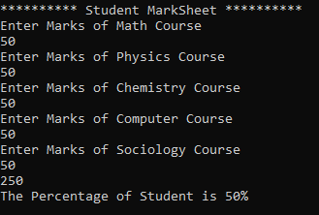

**Task No. 2:** Consume Google Maps Api in Html Webpage.

**Solution:**

**Script File:**

<script>

<script src="https://maps.googleapis.com/maps/api/js?key="></script>

function initMap() {

var mapOptions = {

center: { lat: 3.456, lng: 5.46 },

zoom: 8.6

};

var map = new google.maps.Map(document.getElementById('map'), mapOptions); }

</script>

**HTML File:**

<div id="map"></div>

**Output:**